Report API Details

### **API Description**

#### **Endpoint: /api/reports/report**

This API endpoint is designed to handle requests for saving a report in the form of HTML content. The report can either be stored in a **file** on the server or saved in a **database**, based on the value of the type parameter. The endpoint expects two parameters:

1. **type**: A String parameter that determines where the HTML content should be saved. The allowed values are:
   * "file": Save the report as an HTML file in a specified folder on the server.
   * "database": Save the report HTML content into a database.
2. **htmlContent**: A String representing the HTML content of the report. This content will be saved according to the specified type (either as a file or in the database).

#### **HTTP Method: POST**

* **Request URL**: /api/reports/report

#### 

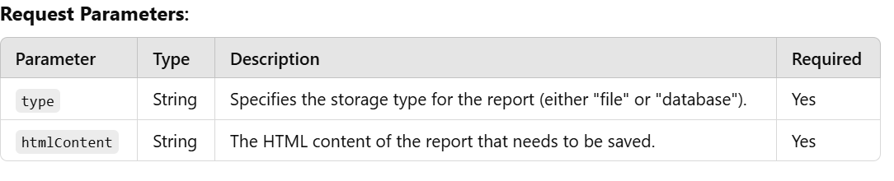

#### **Response:**

* **200 OK**: If the report is saved successfully, a success message is returned:

json  
Copy code  
{

"message": "Report saved successfully."

}

* **500 Internal Server Error**: If an error occurs while saving the report, an error message is returned:

json  
Copy code  
{

"message": "Failed to save report."

}

or, if an exception occurs:

json  
 Copy code  
 {

"message": "Error occurred: <error_message>"

}

**Response Status Codes:**

* **200 OK**: The report was successfully saved.
* **500 Internal Server Error**: An issue occurred during the report saving process (e.g., file system error, database error).

#### **Sample Request:**

**Request URL**: /api/reports/report

**Request Body** (for saving as a file):

json

Copy code

{

"type": "file",

"htmlContent": "<html><body><h1>Report Title</h1><p>This is the report content.</p></body></html>"

}

**Request Body** (for saving to a database):

json

Copy code

{

"type": "database",

"htmlContent": "<html><body><h1>Report Title</h1><p>This is the report content.</p></body></html>"

}

#### **Flow Summary:**

1. **Client Request**: The client sends a POST request to the /api/reports/report endpoint with the type and htmlContent.
2. **Controller Handling**: The ReportController accepts the request and calls the ReportService to handle the saving logic.
3. **Service Logic**:
   * If type is "file", the HTML content is saved as a file in a designated folder.
   * If type is "database", the HTML content is saved to a database (though the actual database saving mechanism can be implemented depending on the use case).
4. **Response**: A success or failure response is returned to the client depending on the outcome of the saving operation.

#### **Use Cases:**

* **Save Report as a File**: When a user needs to generate and store HTML reports as files on the server.
* **Save Report to Database**: When a user wants to store the HTML content of reports in a persistent database for later retrieval.

Flow Diagram

